- An automobile manufacturer is concerned about a fault in the braking mechanism of a particular model. The fault can, on rare occasions, cause a catastrophe at high speed. The distribution of the number of cars per year that will experience the catastrophe is a Poisson random variable with λ = 5.
(a) What is the probability that at most 3 cars per year will experience a catastrophe?
(b) What is the probability that more than 1 car per year will experience a catastrophe?

- Three cards are drawn without replacement from the 12 face cards (jacks, queens, and kings) of an ordinary deck of 52 playing cards. Let X be the number of kings selected and Y the number of jacks. Find
(a) the joint probability distribution of X and Y ;
(b) Find the marginal probability of X dan Y
(c) Check indepency of X and Y

- Consider the random variables X and Y with joint density function
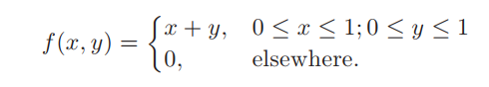
(a) Find the marginal distributions of X and Y .
(b) Find P (X > 0.25, Y > 0.5)

